Optimized Grocery Shopping Route Project Report

Geryes Geryes

Introduction

Imagine walking into a grocery store and knowing exactly where to go to get everything you need without wasting time or letting those frozen peas thaw in your cart. That’s the vision behind this project—optimizing the way we shop for groceries. We all want to get in and out of the store as quickly as possible while keeping our fresh and frozen items in the best condition.

This project tackles the challenge of finding the best shopping route that minimizes both the distance you walk and the time sensitive items spend outside their ideal conditions. Think of it like a classic Traveling Salesperson Problem (TSP) but with a twist—your groceries have different levels of “urgency.” Some items need to stay cool, while others can handle a bit of a wait.

To find the best paths, we’re using two powerful algorithms, NSGA-II and MOEA/D, which help us juggle these competing goals. Through simulations that mimic real store layouts and shopper behaviours, we’re looking to create a practical tool that makes grocery shopping quicker and smarter.

In this report, we’ll walk you through:

* How we’ve defined the problem and set our goals.
* The math and logic behind our optimization approach.
* The algorithms we’ve chosen and why they fit the bill.
* What our experiments showed and how the solutions stack up.
* And finally, what this means for future shopping experiences.

Let’s dive in and see how a bit of clever planning can transform a boring chore into a streamlined experience!

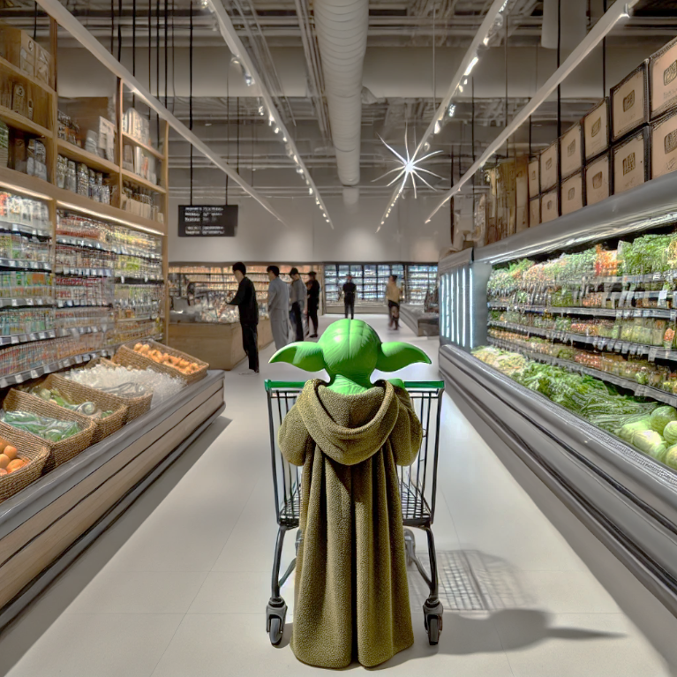  
*"Groceries, I must. Path efficient, find I will!"*

Problem Definition

Navigating a supermarket may seem like a simple task, but without an optimized route, a shopping trip can take much longer than necessary. More critically, **heat-sensitive items**, such as frozen foods and dairy products, degrade over time if left in the cart for too long. This results in lower quality products, potential food waste, and a frustrating shopping experience.

This project aims to optimize the **shopping route** to achieve two main objectives:

1. **Minimize the total distance travelled** within the supermarket to complete the shopping list efficiently.
2. **Minimize the time heat-sensitive items remain in the cart** before checkout, preserving their quality.

**Supermarket Layout & Problem Constraints**

Since we can’t simulate real-world shopping conditions, we model the supermarket as a **grid-based layout**, consisting of:

* **Regular aisles** – Contain standard grocery items.
* **Cold aisles** – Contain heat-sensitive items that degrade over time.
* **Penalty aisles (hot zones)**   
  – Represent areas such as maintenance zones or checkout delays that increase decay rates for heat-sensitive items.
* **Entrance & Exit**   
  – Defines where the shopping trip starts and ends.

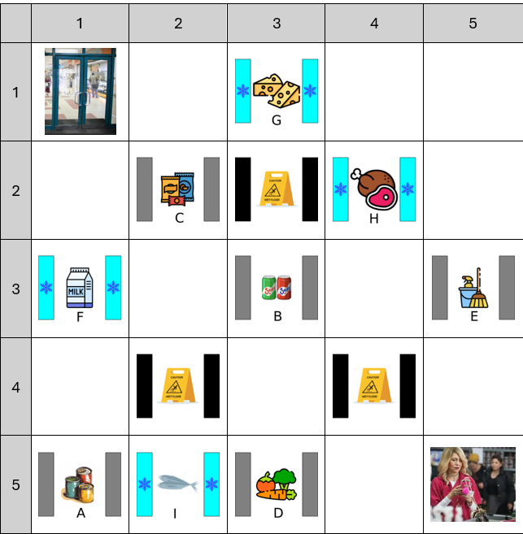Example of Supermarket layout

**Assumptions & Rules:**

* Shoppers must visit all aisles necessary to collect their required items.
* Heat-sensitive items begin decaying **immediately after being picked up**.
* Each shopper follows a **walking pattern**, commonly modelled as:
  + **H2V** (Horizontal to Vertical movement).
  + **V2H** (Vertical to Horizontal movement).
  + **ZgZg** (Zigzag pattern).
* The route optimization must balance between **shortest path** and **item preservation**, preventing one objective from dominating the other.

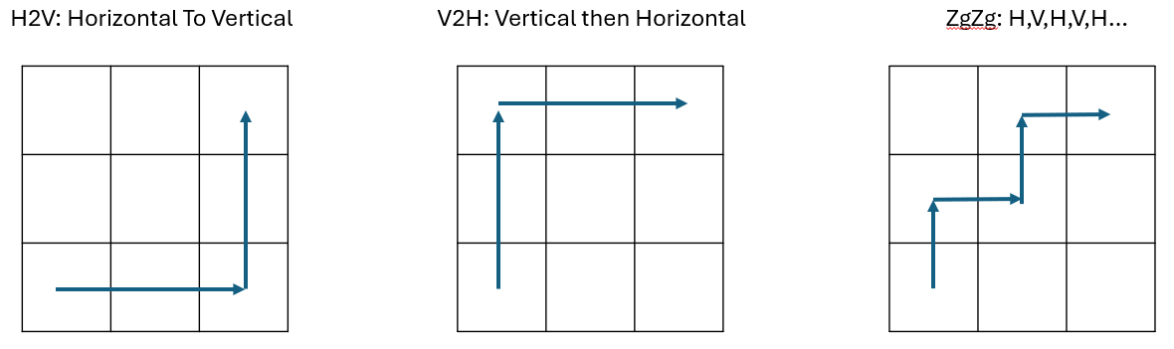

**Challenges in Optimization**

1. **Coupled Objectives:** Since both **travel distance** and **heat exposure** penalties are proportional to time spent in the store, an individual that scores well on one objective will likely score well on the other. These risks turning our problem into a **single-objective problem**, which we must avoid.
   * **Solution:** Introduce **penalty aisles** that affect only the heat sensitivity score to **decouple the objectives**, ensuring a meaningful trade-off.
2. **Crossover and Mutation Complexity:** Like standard Traveling Salesperson Problem (TSP), random crossover and mutation operations in our evolutionary algorithm can easily generate **invalid paths** that don’t respect the aisle constraints.
   * **Solution:** Implement structured crossover and mutation rules that maintain valid supermarket navigation while preserving genetic diversity.

**Summary of Problem Setup**

* The problem is modelled as a **multi-objective path optimization** task.
* Constraints include **grid-based supermarket layouts, heat-sensitive items, and movement rules**.
* The challenge lies in **decoupling the objectives** and ensuring genetic algorithms generate **valid, diverse solutions**.

Optimization Problem Definition

To optimize the supermarket navigation process, we define our problem as a **multi-objective optimization problem** with two competing goals:

1. **Minimizing total travel distance**, ensuring the shortest possible route through the supermarket.
2. **Minimizing heat-sensitive item exposure**, reducing the time such items remain in the cart before checkout.

This section formalizes these objectives mathematically and defines the decision variables, constraints, and search space.

**Decision Variables**

The optimization algorithm must determine the **order of item collection** while navigating the supermarket layout.  
Let:

* be the ordered list of aisle positions where required items are located.
* represent the total distance traveled through all aisles.
* represent the time heat-sensitive items remain in the cart.

The solution space consists of all valid paths respecting **aisle constraints and movement patterns**.

**Objective Functions**

We define two primary objectives:

**1. Minimize Total Distance Traveled**

where:

* is the distance between two consecutive item locations.
* is the total number of aisles visited.

This function ensures that the overall shopping route is as short as possible.

**2. Minimize Heat-Sensitive Item Exposure**

where:

* is the number of heat-sensitive items picked up.
* is the time elapsed from picking up item until checkout.
* **Penalty is applied** if a route includes a **hot/maintenance aisle**, increasing exposure time.

This function ensures that perishable items remain in ideal conditions for as long as possible.

**Constraints**

The optimization is subject to the following constraints:

1. **Valid Supermarket Path**
   * The path must **respect aisle constraints** and shopper movement rules (H2V, V2H, or ZgZg).
   * The path must be **continuous** and must not skip aisles with required items.
2. **Start and End at Entrance/Exit**
   * The shopping trip always starts at the store entrance and ends at checkout.
3. **Item Pickup Order Affects Exposure**
   * The order in which heat-sensitive items are picked up **affects the exposure time penalty**.
4. **Penalty Aisles (Hot Zones)**
   * If a shopper crosses a penalty aisle, **additional heat-exposure time is added** to the total decay function.

**Search Space & Feasibility**

The search space consists of all **valid routes** a shopper can take while obeying constraints.

* A naïve **brute-force search** is computationally infeasible due to factorial growth in path possibilities.
* A **multi-objective genetic algorithm (MOEA)** is used to find **Pareto-optimal solutions**, balancing both objectives.

To **diversify solutions**, crossover and mutation strategies must **maintain valid aisle paths** while allowing genetic exploration.

Problem Complexity

**Summary**

* The problem is a **multi-objective routing challenge** balancing **distance and heat-sensitive exposure**.
* The decision variables define **valid supermarket paths** while optimizing **route efficiency**.
* Constraints ensure **realistic shopping behaviours**, including penalty zones.
* The complexity requires **advanced MOEA-based optimization** instead of brute-force or simple heuristics.

This mathematical foundation enables the next step: **implementing genetic algorithms** to solve the problem effectively.